**Background and Motivation:**

As the internship summer is approaching, our team wanted to help the peer classmates have some insights of the companies they intend to work for. We have focused on the banking industry and have chosen three major banks in Georgia - Chase, SunTrust, and BB&T. Our analysis primarily is helpful to peers who have a financial education background and interested in pursuing a career in the banking industry.

The data source is from Indeed.com. We have scrapped employee reviews for their location (where this branch is located), position(job titles), review content, ratings(from 1 to 5), and the date of the reviews posted. We further analyzed the reviews regarding these aspects. Hopefully after the analysis, our peer classmates could have a better idea when searching and applying for internships.

**Data Collection**

Banking industry was selected as the target and SunTrust, BB&T and Chase were selected for sentiment analysis. The team collected company reviews by BeautifulSoup in Python. The total number of reviews for SunTrust, BB&T and Chase are 2001, 1401 and 1382 respectively. The company reviews include information about location, position, reviews, ratings and date. Table 1 is data sample.

Table 1 Data Sample of Company Reviews

|  |  |  |  |  |
| --- | --- | --- | --- | --- |
| **Location** | **Position** | **Reviews** | **Ratings** | **Date** |
| Smyrna, GA | Analyst (Current Employee) | The bank is constantly understaffed so the ... | 3 | August 15, 2017 |
| Atlanta, GA | Treasury  (Former Employee) | Whether you are looking to apply at SunTrust, ... | 1 | November 5, 2019 |
| Fort Myers, FL | Teller (Current Employee) | I enjoy working for SunTrust. Although ... | 5 | November 4, 2019 |
| **...** | **...** | **...** | **...** | **...** |

**Hypothesis:**

Firstly, we would like to see and compare the overall reviews for three companies in order to have a general sense of their working environment and how are they treating their employees in general.

Next, we would like to parse down the reviews into mainly four aspects of employment- work and life balance, job security, personal growth, and payment & benefits. Different banks may have their unique advantages, and we are interested to find out the area that each company has an edge on by comparing the sentiments of each of the four aspects specifically.

Lastly, we will analyze the overall reviews for three banks regarding time, location, and job titles. Essentially, we would like to see if there are interesting trends in the sentiment. For example, we may find that one company performs differently through diverse locations, meaning that working in a particular state is much better than in the other states; one company is treating employees in a discriminate way based on their job title; and finally, one company is working hard to improve the working environment for its employees while another on the contrary does not do much improvement, if not getting worse.

Above are the main hypothesis we intent to test.

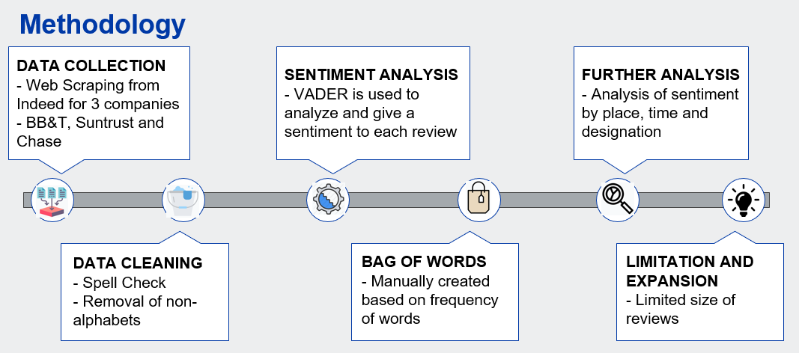

**Methodology:**

**Data Collection**: To collect the reviews of our three companies, we scrapped indeed.com. From the website, we were able to retrieve date of review, designation of reviewer, whether the reviewer is currently working or has left the company, review and the rating given by the reviewer. For each company, we scrapped approximately two thousand reviews.

**Data Cleaning :** The data scrapped had noise which had to be removed before we could begin with or analysis.

**Sentiment Analysis:** Got the sentiment of each review by using Vader. **VADER (Valence Aware Dictionary and Sentiment Reasoner)** is a lexicon and rule-based sentiment analysis tool that is specifically attuned to sentiments expressed in social media. VADER uses a combination of A sentiment lexicon is a list of lexical features (e.g., words) which are generally labeled according to their semantic orientation as either positive or negative. VADER not only tells about the Positivity and Negativity score but also tells us about how positive or negative a sentiment is.

**Bag of Words**: We created a list of words from the corpus and their frequency. We mapped the words that are associated with different aspects which may affect an individual in work life. These aspects comprise of personal development, career growth, leadership, management and perks and benefits. Then we got the average sentiment of all the lines that contained these words to get a sense of sentiments for these aspects.

**Further Analysis:** For deeper analysis, we compared the sentiments of these companies based on geography, designation of reviewers and time series analysis.

**Limitation and Expansion:** The biggest hurdle in our project was that we had a limited number of reviews for each aspect of working life. If we could collect more data for the location and designation of the reviewer we could support our conclusions more confidently

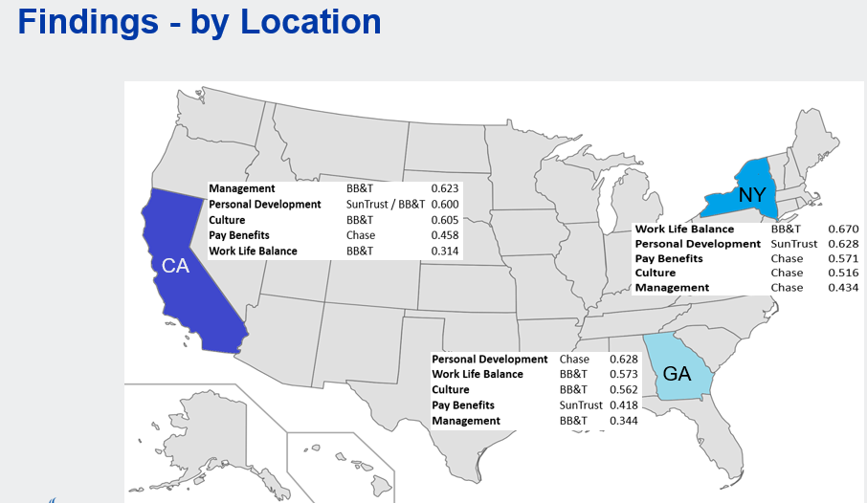

* Eastern coast being the financial hub of the United States performs better than Western coast.
* New York outperforms the rest of the states.
* Chase is best to work in New York with highest sentiments in pay benefits, culture and management.
* BB&T is better to work in California and Georgia

Analysis By Time:   
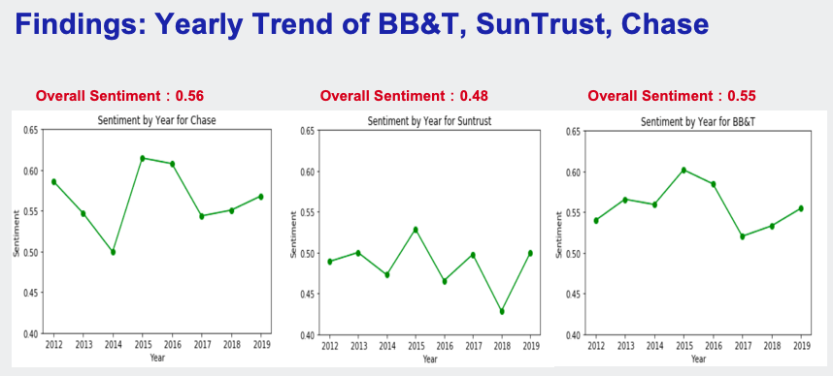

Based on five years’ review we have scrapped, we are able to analyze the yearly sentiment trends for three major banks in Georgia as comparison. According to the graph, SunTrust has the lowest overall sentiment compared to Chase and BB&T, with most volatile reviews as well. While BB&T and Chase have similar sentiment on average, BB&T has the relatively less volatile reviews over the years. Therefore, if a person is looking for job security when choosing the banks to work for, BB&T is better than the other two. While 2017 seems to be a bad year for all three banks that we are investigating here, the reason behind remain unclear through research.

In terms of predicting next year’s sentiment, all three banks seem to have an increasing trend since 2017. Under this assumption, choosing either one to work for next year is presumably indifferent. On the other hand, if we take 3 year as one period, it is likely that they all will have a decreased sentiment next year, as 2019 could be a new start for another 3-year decreasing cycle. Regardless, with SunTrust having the most potential to improve its working environment judging from its volatility, we are uncertain to give a positive answer about what the review would be exactly for next year. In the future, in order to have a better prediction, we will increase the time period of data collection and expand the review source from multiple websites as well.

Sentiment Analysis-by Designation:

In this part, the team analyzed the sentiments by designation. In order to learn deeper about the situation of our own major, reviews from “Analyst” were selected and applied sentiment analysis. Bank teller, as a conmen position in bank industry, was analyzed as a comparison to analyst. For analysts and tellers in SunTrust, BB&T and Chase, the team calculated the overall sentiment (mean score), sentiments in terms of work-life balance, pay benefits, job security, culture, management and personal development. The results are shown as Table 2.

Table 2 Sentiments of Analyst and Teller

|  |  |  |  |  |  |  |
| --- | --- | --- | --- | --- | --- | --- |
| **Sentiment** | **SunTrust** | | **BB&T** | | **Chase** | |
| **Analyst** | **Teller** | **Analyst** | **Teller** | **Analyst** | **Teller** |
| Count | 137 | 336 | 79 | 281 | 61 | 338 |
| Overall Sentiment | 0.560 | 0.477 | 0.650 | 0.522 | 0.498 | 0.645 |
| Work Life Balance | 0.531 | 0.087 | 0.306 | 0.210 | 0.359 | 0.200 |
| Pay Benefits | 0.252 | 0.279 | 0.683 | 0.359 | 0.649 | 0.443 |
| Job Security | -0.245 | -0.314 | 0.255 | -0.195 | nan | 0.143 |
| Culture | 0.431 | 0.440 | 0.502 | 0.504 | 0.410 | 0.568 |
| Management | 0.280 | 0.236 | 0.408 | 0.344 | 0.455 | 0.440 |
| Personal Development | 0.450 | 0.354 | 0.226 | 0.244 | 0.457 | 0.467 |

Some insights are shown in Figure 3.

• For an analyst role, the overall environments are similar in all three companies. Overall sentiment of BB&T is slightly higher than others. Sentiments in terms of work-life balance, payment and benefits and job security are of big difference.

• For sentiment of work life balance, analysts in Sun Trust have the highest score. Usually, analysts feel better on balanced life compared with tellers.

• Analysts in BB&T have highest score for payment and benefits. Analysts usually have higher sentiment than tellers except SunTrust.

• Analysts in SunTrust have negative sentiment about job security, but it is still better than sentiment of tellers. In contrast, analysts in BB&T have a positive sentiment about job security.

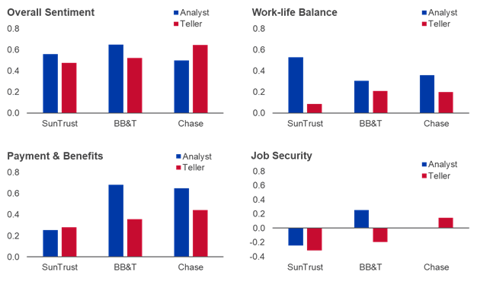

Figure 3 Overall sentiment, sentiments of work-life balance, payment and benefits and job security by designation

**Summary**

In this project, the team collected company reviews of three bank company from Indeed.com and analyze the sentiment based on these reviews. Sentiment analysis tool VADER provides positive or negative score for each review and then, the team analyze the overall sentiment and sentiment in 6 aspects: work-life balance, pay benefits, job security, culture, management and personal development for different years, locations and designations. Recommendations are given as followed.

· At an overall level, Chase has the best working environment and benefits.

· Based on Yearly trend, BB&T has least volatile reviews, SunTrust has the most volatile ones. Hence, BB&T may be better to choose for people who are seeking job security.

· If you would like to work in New York, Chase is recommended. For people who potentially work in California or Georgia, BB&T will be best for you.

· For an analyst role, the overall environments are similar in all three companies. Join SunTrust for a balanced life and join BB&T for a higher pay.